FAIRVOICE DEEP LEARNING PROJECT REPORT

Enhancing Interpretability and Equity in Speech Emotion Recognition Using RADVESS

Author: Bernice Agyeiwaa Amponsah

- Abstract
In this project, I studied speech emotion recognition with a focus on gender bias and fairness. I used the RAVDESS dataset to train and evaluate different machine learning models for emotion classification from speech. I first implemented a baseline Long Short-Term Memory (LSTM) model, followed by a stronger Transformer-based model combined with a Support Vector Machine (SVM). I evaluated model performance using accuracy and F1 score and assessed gender bias by comparing results across male and female speakers. I also applied SHAP to explain model predictions. Finally, I implemented adversarial debiasing to reduce gender bias in the model. The results show that models with higher accuracy may still exhibit bias, while fairness-aware models reduce bias at the cost of performance. This work highlights the trade-off between accuracy and fairness in speech emotion recognition systems.

- Introduction
Speech emotion recognition is the task of identifying human emotions from speech signals. It is used in applications such as virtual assistants, mental health support systems, and customer service tools. These systems rely on machine learning models that learn emotional patterns from audio data.
However, speech emotion recognition models can show biased behavior across demographic groups. Gender bias is a common issue, where a model performs better for one gender than the other. Such bias can reduce fairness and trust in automated systems.
In this project, I focused on building and evaluating speech emotion recognition models while examining gender bias. I used the RAVDESS dataset because it contains labeled emotional speech with gender information. I trained multiple models, including a baseline LSTM model and a Transformer-based model with an SVM classifier. I evaluated gender bias using accuracy and F1 score comparisons. I also applied SHAP to understand which features influenced model predictions. Finally, I used adversarial debiasing to reduce gender bias and examined how this affected model performance.
The objectives of this project are:
- To evaluate the performance of different speech emotion recognition models
- To analyze gender bias in model predictions
- To apply and assess a fairness mitigation technique

- Dataset and Preprocession
In this project, I used the Ryerson Audio-Visual Database of Emotional Speech and Song (RAVDESS). The dataset contains speech recordings labeled with emotional categories and speaker information, including gender. I focused on four emotion classes: angry, sad, happy, and neutral. Gender labels were limited to male and female speakers.
Each audio file was sampled at 16 kHz to ensure consistency. I extracted Mel-Frequency Cepstral Coefficients (MFCCs) from the speech signals, as MFCCs are commonly used features for speech and emotion recognition tasks. For each audio file, I extracted 40 MFCC coefficients and fixed the time dimension by either padding or truncating the sequence. This ensured that all samples had the same shape before being passed to the models.
I created a metadata file that included the file path, emotion label, and gender label for each sample. Emotion labels were mapped to numeric values to support model training. Gender labels were also converted into numeric form to support bias analysis and fairness mitigation.
Before training, I split the dataset into training and testing sets. The training set was used to learn model parameters, while the test set was used for evaluation. This separation ensured that model performance was measured on unseen data.

- Feature Representation
MFCC features were chosen because they capture important frequency characteristics of human speech that are relevant to emotion recognition. Each audio file was represented as a two-dimensional MFCC matrix. This representation preserves both spectral and temporal information in the speech signal.
To make the features compatible with neural networks, I converted the MFCC matrices into fixed-length tensors. This step was necessary for batch processing and stable training. The same feature extraction process was applied consistently across all models to ensure fair comparison.

- Models and Training
In this project, I trained and evaluated three different models for speech emotion recognition. Each model was trained using the same feature extraction process to ensure a fair comparison.

  - Baseline LSTM Model
I first implemented a baseline Long Short-Term Memory (LSTM) model. The LSTM model was chosen because it is suited for sequential data such as speech. The model takes MFCC feature sequences as input and produces emotion predictions based on temporal patterns in the audio signal.
The baseline LSTM consists of an LSTM layer followed by a fully connected layer that outputs emotion class scores. The model was trained using cross-entropy loss and the Adam optimizer. This baseline model serves as a reference point for evaluating performance and bias.

  - Transformer with SVM Classifier
To improve performance, I implemented a Transformer-based model combined with a Support Vector Machine (SVM) classifier. The Transformer was used to extract high-level representations from the MFCC features. These representations were then used as input to an SVM classifier for emotion prediction.
This approach achieved the best overall performance in the project. After improvements, the Transformer plus SVM model achieved higher accuracy and F1 score compared to the baseline LSTM. This model demonstrates the benefit of using stronger feature representations for speech emotion recognition.

  - Training Setup and Evaluation Metrics
All models were trained using the same train-test split to ensure consistent evaluation. Model performance was evaluated using accuracy and weighted F1 score. Accuracy measures the proportion of correctly classified samples, while F1 score balances precision and recall across emotion classes.
These metrics were chosen because they provide a clear view of both overall performance and class-level behavior. They were later used for bias assessment and fairness comparison.

- Bias Assessment
After training the models, I evaluated gender bias by comparing performance across male and female speakers. Gender bias was measured using accuracy and weighted F1 score computed separately for each gender group. This analysis helped to identify whether a model performed consistently across genders or favored one group over the other.
I first evaluated the baseline LSTM model. The results showed noticeable differences in performance between male and female speakers, indicating the presence of gender bias. This was expected given the low overall performance of the baseline model and the limited capacity of the learned representations.
I then evaluated the Transformer plus SVM model. Although this model achieved higher overall accuracy and F1 score, gender-based performance differences were still observed. This shows that improved accuracy does not automatically eliminate bias and that strong models can still produce unfair outcomes.
To support this analysis, I used confusion matrices and gender-based performance summaries. These summaries provided insight into how prediction errors differed between male and female speakers.

Gender bias summary metrics
Model | Accuracy_gap | f1_gap
LSTM | 0.0065934065934066255 | 0.005250305250305259
Transformer | 0.05494505494505497 | 0.053422462501520496

Gender Performance Gap Visualization
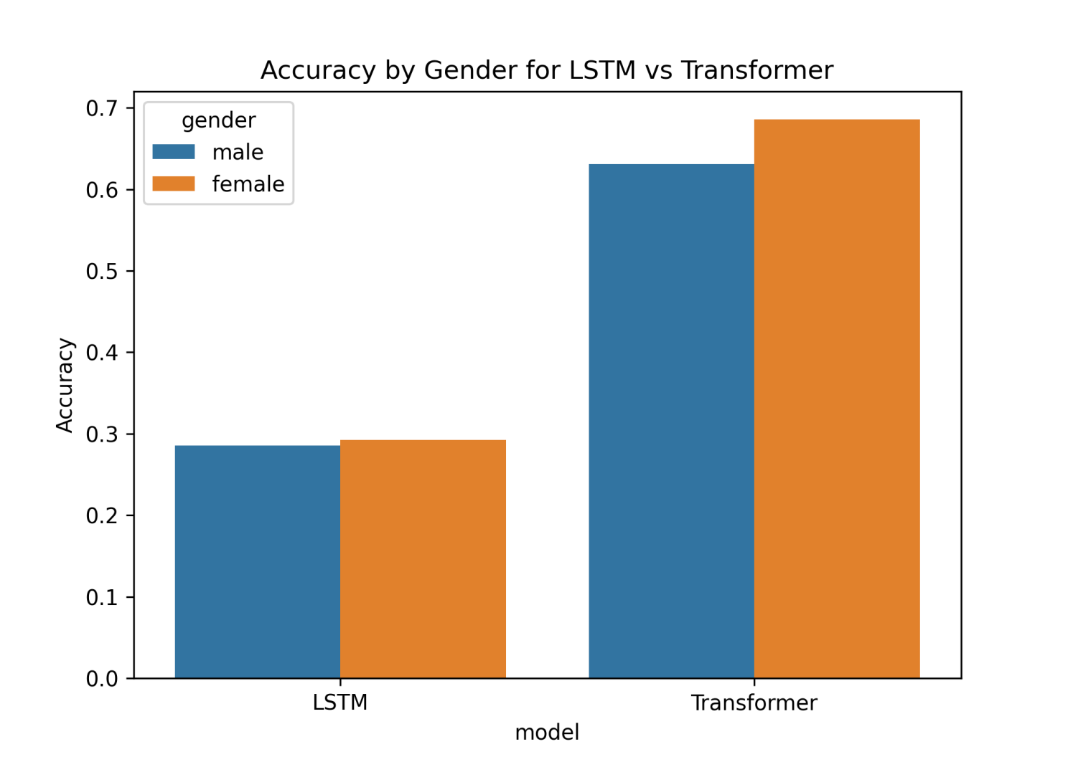
This figure shows the difference in model accuracy between male and female speakers. A visible gap indicates that the model performs better for one gender than the other. This confirms the presence of gender bias in the model and motivates the need for fairness analysis and mitigation.

Baseline LSTM Confusion Matrix
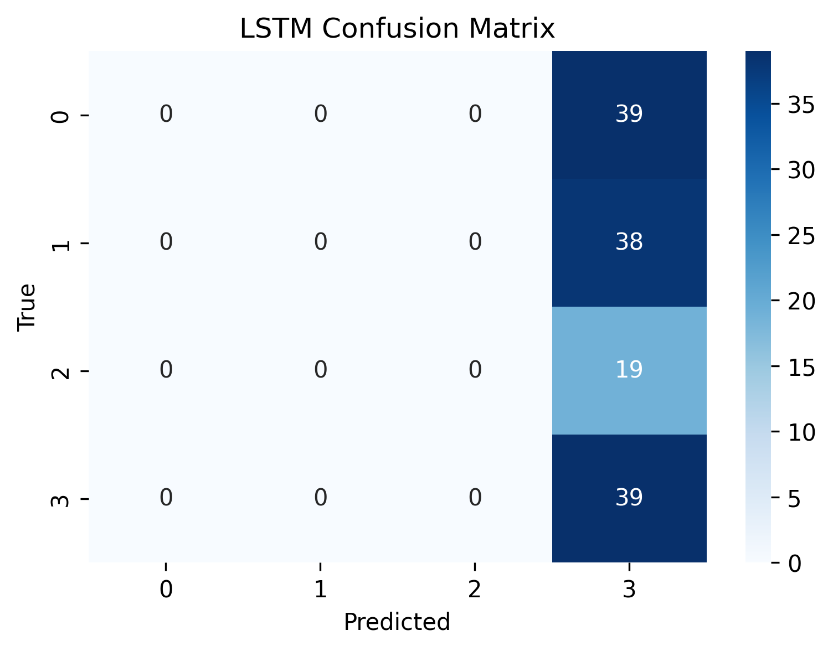

The confusion matrix for the baseline LSTM model shows frequent misclassification across emotion classes. Errors are distributed unevenly, which contributes to both low accuracy and gender bias. This result highlights the limitations of the baseline model.

Transformer Plus SVM Confusion Matrix
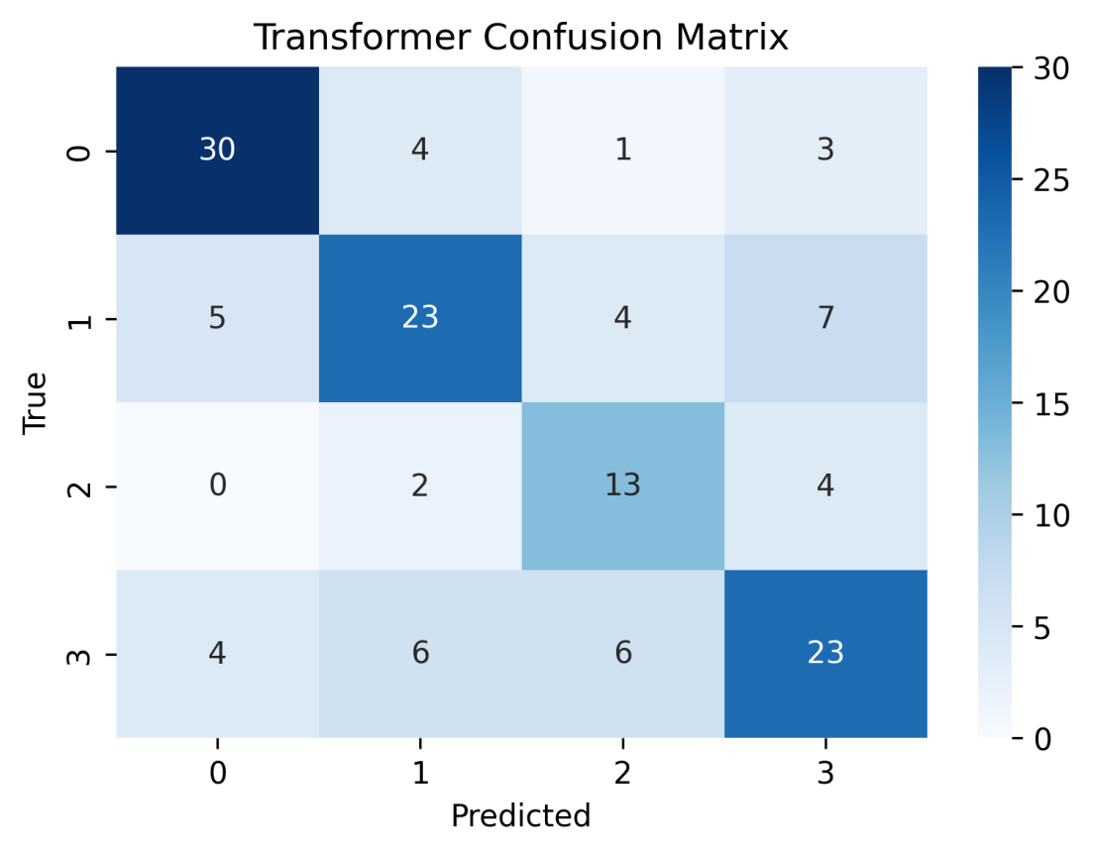

The confusion matrix for the Transformer plus SVM model shows improved classification compared to the baseline LSTM. Correct predictions are more frequent across emotion classes. However, some misclassifications remain, which may still contribute to gender bias.

- Model Explainability
To better understand how the models made their predictions, I applied model explainability techniques. Explainability is important because it helps reveal which features influence model decisions and whether these influences differ across demographic groups such as gender.
I used SHAP (SHapley Additive exPlanations) to analyze the Transformer plus SVM model. SHAP assigns an importance value to each feature, indicating how much it contributes to a prediction. This approach allows for both global and local interpretation of model behavior.
I first generated a SHAP summary plot to identify the most influential features across all predictions. This plot shows how different MFCC features contribute positively or negatively to emotion classification. I also generated a SHAP beeswarm plot to visualize the distribution of feature contributions across samples.
To further examine gender-related effects, I generated separate SHAP summaries for male and female speakers. Comparing these plots helped identify whether the model relied on different features when predicting emotions for different genders.

SHAP Summary Plot
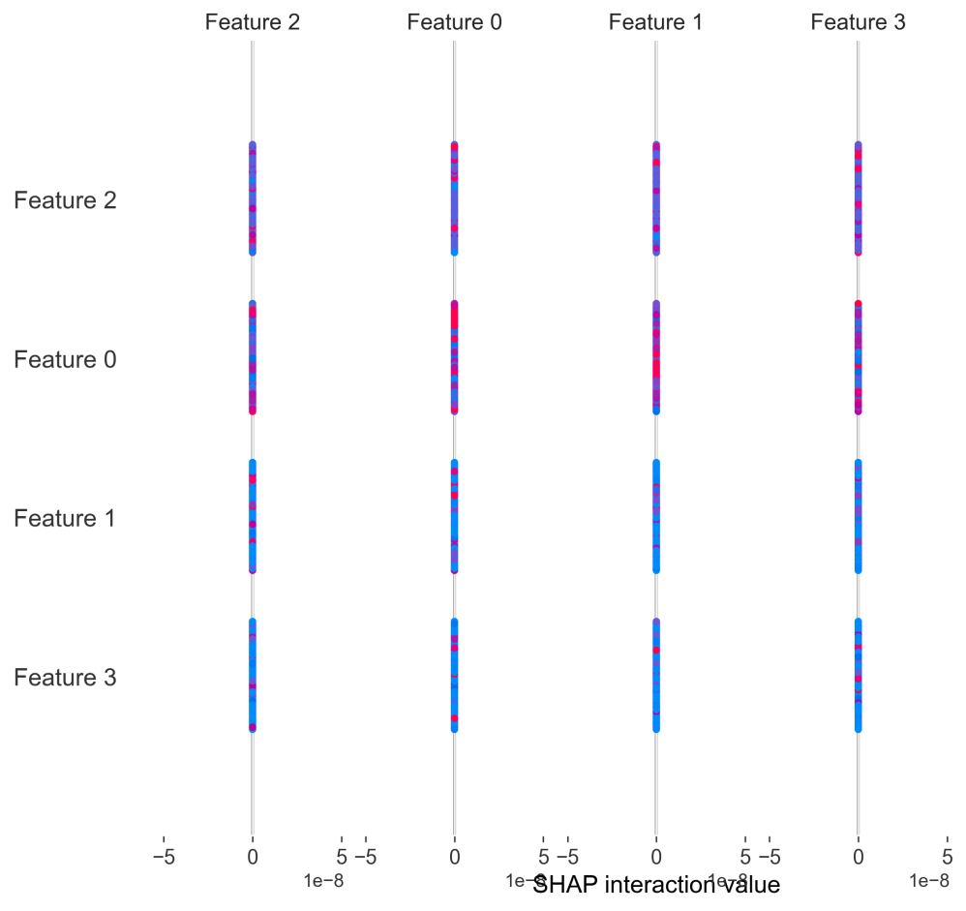

This SHAP summary plot shows the most influential MFCC features used by the model when predicting emotions. Features with larger SHAP values have a stronger impact on the predictions. This plot provides a global view of how the model makes decisions.

SHAP Beeswarm Plot

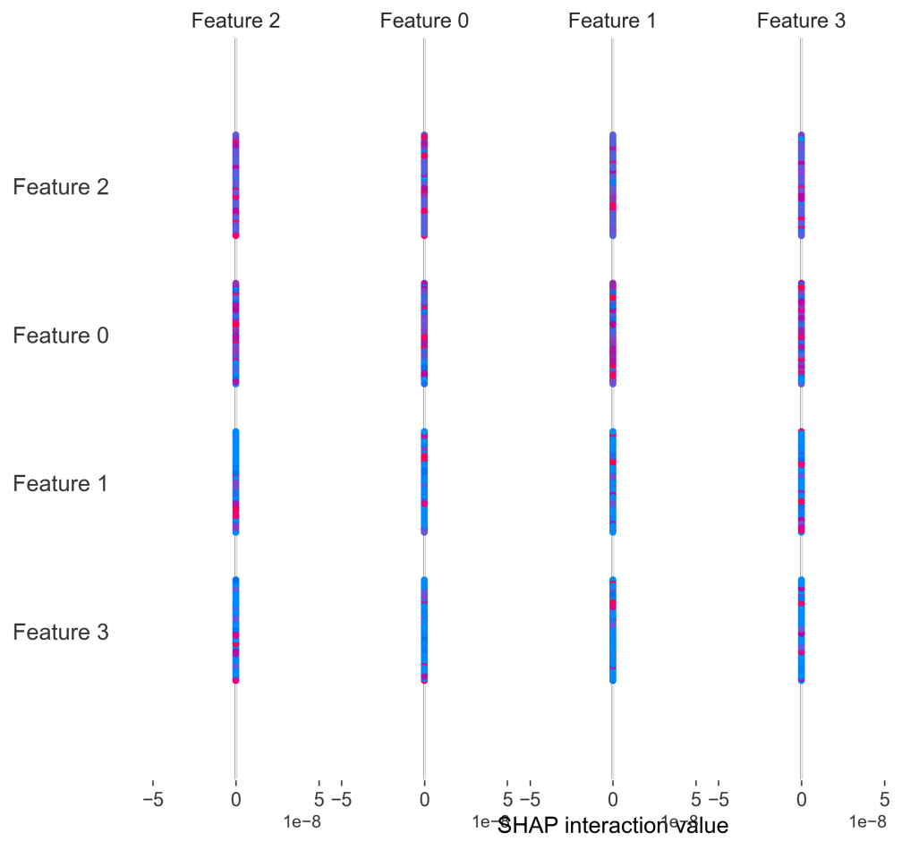

The SHAP beeswarm plot illustrates the distribution of feature contributions across all samples. It shows how individual MFCC features affect predictions differently depending on their values. This helps explain variability in model behavior across samples.

- Fairness Mitigation
After identifying gender bias in the emotion recognition models, I applied a fairness mitigation technique to reduce this bias. The goal of this stage was not to improve overall accuracy, but to make the model’s predictions more balanced across male and female speakers.
I used an adversarial debiasing approach based on a Long Short-Term Memory (LSTM) model. The pretrained baseline LSTM was used as a feature extractor. An additional adversarial network was introduced to predict gender from the learned features, while the main model continued to predict emotion. A gradient reversal mechanism was used so that the feature extractor learned representations that were useful for emotion prediction but less informative about gender.
During training, the model optimized two objectives at the same time. The emotion classification loss was minimized, while the gender prediction loss was maximized through the adversarial component. This forced the model to reduce the amount of gender-related information in its internal representations.
After training, I evaluated the debiased model using the same metrics as before. The results showed a clear reduction in gender performance differences compared to the baseline model. However, overall accuracy and F1 score decreased. This outcome demonstrates the trade-off between fairness and performance. Reducing bias led to a loss of predictive power, especially given the weak baseline model used as the backbone.

Gender Bias Metrics After Adversarial Debiasing

Gender | Accuracy | F1
Male | 0.2857142857142857 | 0.12698412698412698
Female | 0.2857142857142857 | 0.12698412698412698

Gender Gap After Adversarial Debiasing
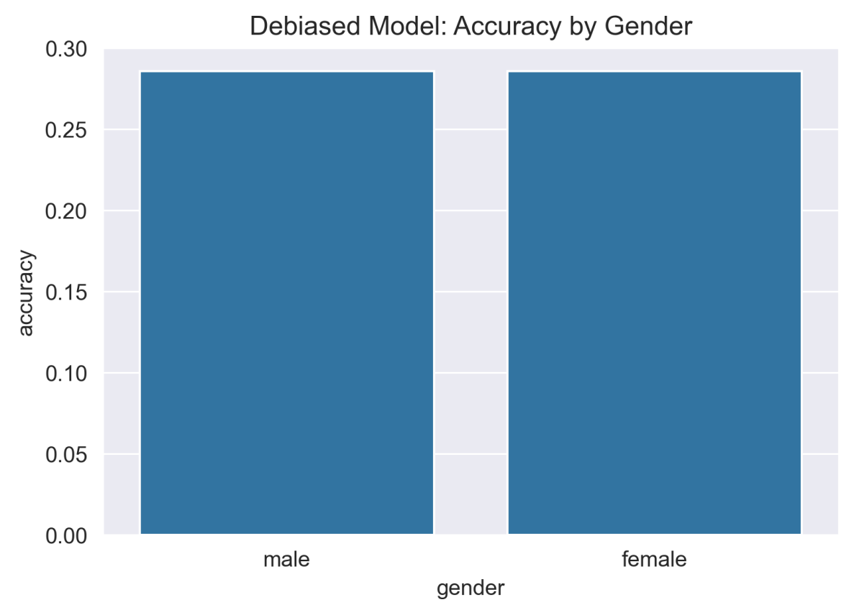

This figure shows gender-based accuracy after applying adversarial debiasing. The smaller difference between male and female performance indicates improved fairness. At the same time, the overall reduction in accuracy highlights the trade-off between fairness and performance in speech emotion recognition models.

- Results and Discussion
In this section, I compare the performance, bias, and fairness of all models developed in this project. The goal is to understand how model choice affects accuracy and gender fairness in speech emotion recognition.
I evaluated three models: the baseline LSTM model, the Transformer plus SVM model, and the adversarially debiased LSTM model. Each model was assessed using accuracy and weighted F1 score, and gender bias was examined by comparing results for male and female speakers.
The baseline LSTM model achieved low accuracy and F1 score. It also showed noticeable gender bias, with different performance levels for male and female speakers. These results indicate that the baseline model was not strong enough to capture emotion-related patterns effectively and served mainly as a reference model.
The Transformer plus SVM model achieved the highest accuracy and F1 score in the project. This model demonstrated strong emotion recognition performance compared to the baseline LSTM. However, despite its improved accuracy, gender-based performance differences were still present. This shows that higher predictive performance does not automatically eliminate bias.
The adversarially debiased LSTM model showed reduced gender bias compared to the baseline model. Performance differences between male and female speakers were smaller after applying adversarial debiasing. However, this improvement in fairness came at the cost of reduced overall accuracy and F1 score. This result highlights the trade-off between fairness and performance, especially when fairness constraints are applied to a weak base model.
Overall, the results show that different models offer different strengths. The Transformer plus SVM model is the best choice when accuracy is the main objective. The adversarially debiased model is more appropriate when fairness is a priority, even if performance is reduced. These findings demonstrate that fairness-aware model design requires careful consideration of trade-offs.

Final Model Comparison
Model | Accuracy | F1 | Fairness_level
Baseline LSTM | 0.2889 | 0.1295 | Low
Transformer + SVM (Improved) | 0.6593 | 0.6589 | Medium
Adversarial LSTM (Debiased) | 0.2857 | 0.1275 | High

Accuracy Versus Fairness Trade-off
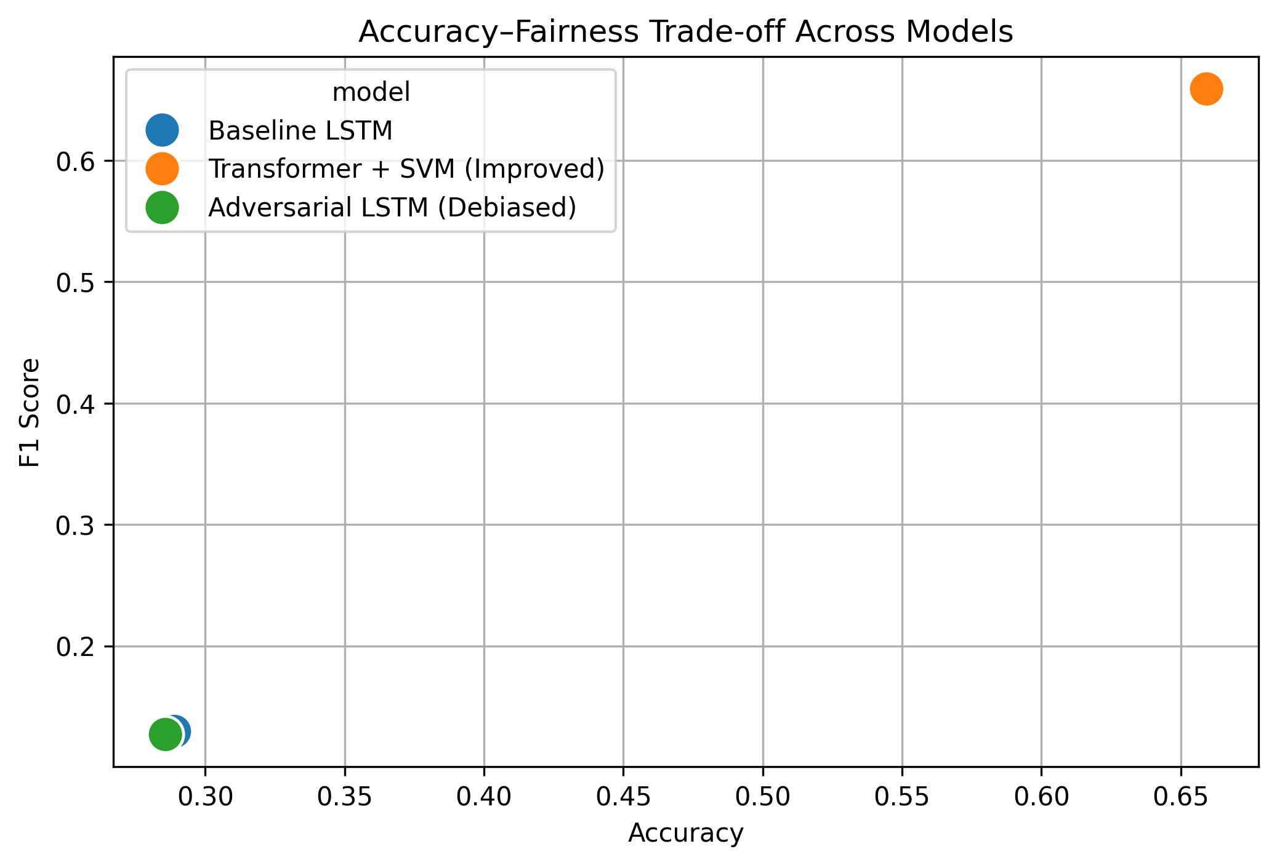

This figure illustrates the relationship between accuracy and fairness across the evaluated models. The Transformer plus SVM model achieves high accuracy but moderate fairness, while the adversarially debiased model achieves improved fairness with lower accuracy. This visual comparison reinforces the presence of an accuracy–fairness trade-off.

10.1 Conclusion
In this project, I investigated speech emotion recognition with a focus on gender bias and fairness. I trained and evaluated multiple models using the RAVDESS dataset, including a baseline LSTM model, a Transformer-based model with an SVM classifier, and an adversarially debiased LSTM model. I assessed model performance using accuracy and F1 score and analyzed gender bias by comparing results for male and female speakers.
The results showed that the Transformer plus SVM model achieved the highest accuracy and F1 score, making it the most effective model for emotion recognition. However, this model still exhibited gender bias. The baseline LSTM model performed poorly and also showed bias. The adversarially debiased LSTM model reduced gender bias, but this improvement came at the cost of lower overall performance. These findings demonstrate a clear trade-off between accuracy and fairness in speech emotion recognition systems.
This project highlights the importance of evaluating both performance and fairness when developing machine learning models. High accuracy alone does not guarantee fair behavior across demographic groups. Fairness-aware techniques can reduce bias, but they must be applied carefully to avoid excessive performance loss.

10.2 Proposed Solutions for Improving Fairness and Robustness

Based on the findings of this project, several approaches can be proposed to improve fairness and robustness in future work. First, using a stronger base model for adversarial debiasing could help reduce the performance drop observed in the debiased LSTM. Applying fairness constraints to a more expressive model may result in better overall outcomes.
Second, increasing dataset diversity could improve robustness and fairness. Collecting or using datasets with more balanced gender representation and greater variation in speakers, accents, and speaking styles would help models generalize better and reduce bias.
Third, combining multiple fairness mitigation techniques could be explored. For example, reweighting training samples or using data augmentation alongside adversarial debiasing may improve fairness without significantly harming performance.
Finally, fairness evaluation could be extended beyond gender to include other sensitive attributes if available. Continuous monitoring of bias during model development and deployment would also help ensure that models remain fair over time.
In conclusion, this project demonstrates that fairness is a critical aspect of speech emotion recognition. Addressing bias requires deliberate design choices, careful evaluation, and a willingness to accept trade-offs between performance and fairness.

